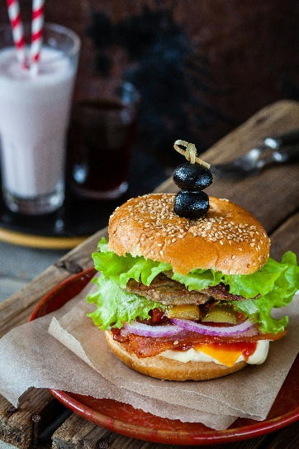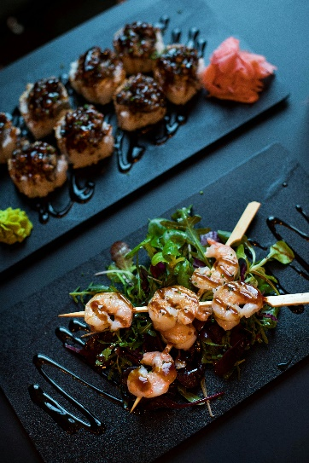

"Indulge in restaurant-quality meals delivered straight to your door. Our kitchen uses only the freshest ingredients, expertly prepared to bring you a delicious and convenient dining experience. From our door to yours, enjoy high-quality flavours in every bite."

**Made with passion, delivered with pride.**

**Home Products About Contact**

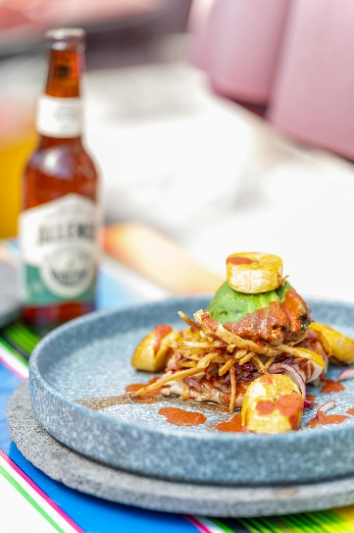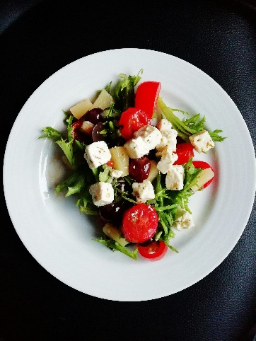

**Home Products About Contact**

Load More

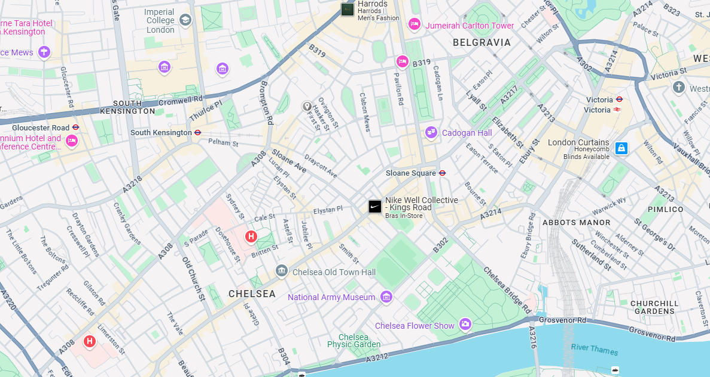

Come dine with us

**123 Fleet Street,**  
**London, EC4A 2AB,**  
**United Kingdom**

At [Restaurant Name], we believe that great food starts with the best ingredients and ends with a memorable experience. That’s why we’re committed to bringing you high-quality, freshly prepared meals – delivered straight to your door.

Our chefs craft each dish with care and passion, using only the finest ingredients sourced from trusted suppliers. Whether you’re craving something comforting or looking to try something new, our diverse menu has something to satisfy every taste.

We’re all about convenience, without compromising on quality. Our team works diligently to ensure your meal arrives fresh, hot, and ready to enjoy – because you deserve more than just takeout.

Join us on a culinary journey, where delicious food is just a click away.



Email Form

Keep up to date with new additions and sales

contact@freshbitekitchen.com

Email

(+44) 020 7946 0852

Phone Number

**123 Fleet Street, London, EC4A 2AB, United Kingdom**

Address